**Solo Protocol Test Study Guide 2023**

SMART – Surgical Airway: **S**urgery/Scars, **M**ass/Hematoma, **A**ccess/Anatomy, **R**adiation treatment, **T**umor

RODS – Difficulty BIAD: **R**estricted Mouth Opening/**R**adiation, **O**bstruction/**O**B/**O**bese/**O**bstructive Sleep Apnea, **D**istorted/**D**isrupted Airway, **S**tiff lungs/Stiff neck

ROMAN– **R**estricted Mouth Opening/**R**adiation, **O**bstruction/**O**B/**O**bese: **M**ask seal, **A**ge > 55, **N**o Teeth

LEON – Difficult Laryngoscopy: **L**ook externally for anatomical issues, **E**valuate 3-3-2, **O**bstruction/**O**B/**O**bese/**O**bstructive Sleep Apnea, **N**eck mobility limited

CRAM – Refusal: **C**ommunicate clear choice consistently over time, **R**elevant info is understood, **A**ppreciation of the situation, **M**anipulation of info in a rational manner to make decision

SAFER – Behavioral Crisis: **S**tabilize the situation (lowering stimuli, removing personnel), **A**ssess and acknowledge crisis, **F**acilitate resources (family, friends, etc), **E**ncourage patient to use resources, **R**ecovery/Referral (Patient in care of responsible person/transport as appropriate)

NSAIDS – Spinal Motion Restriction: **N**euro Exam/Focal Deficit, **S**ignificant **M**echanism of injury, **A**lertness, **I**ntoxication, **D**istracting Injury, **S**pinal Exam

SLUDGE – Cholinergic Exposure: **S**alivation, **L**acrimation, **U**rination, **D**efecation, **GI** distress, **E**mesis

DUMBBELS – Cholinergic Exposure: **D**iarrhea, **U**rination, **M**iosis (Pinpoint Pupils), **B**radycardia, **B**ronchorrea, **E**mesis, **L**acrimation, **S**alivation

**Radiation Exposure Protection** – Distance, Time and Shielding from source

**Blast Injuries**  
Primary – Pressure Wave  
Secondary (Most Common) – Impaled Objects, Debris that becomes missiles  
Tertiary – Patient falling or being thrown/pinned by debris

**Burns – Rule of 9s**

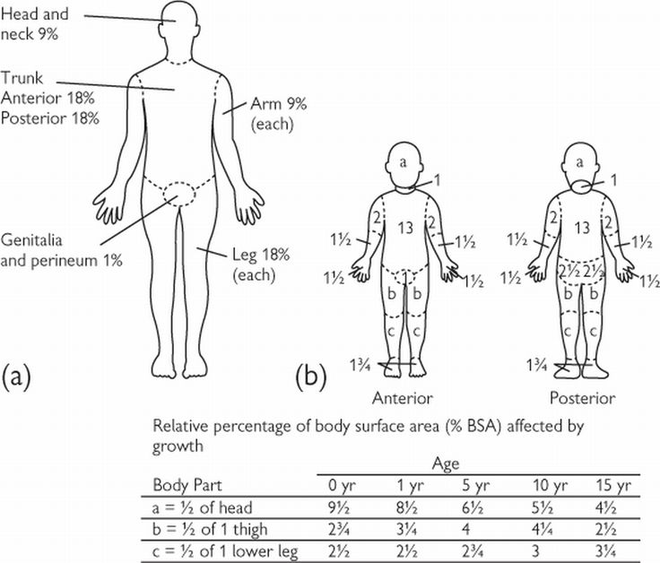

**Parkland Formula (> 20% TBSA) 0.25mL/kg x (TBSA %)/hr**

Over 20% TBSA: <5 yo 125mL/hr  
 6-14 yo 250mL/hr  
 >15 yo 500mL/hr

**Critical or Serious Burns:**  
>5-15% TBSA 2nd or 3rd degree  
3rd degree burn (full thickness) >5% TBSA for any age  
Circumferential burns of extremities  
Electrical or lightning injuries  
Suspicion of abuse or neglect  
Inhalation injury  
Chemical burns  
Burns of the face, perineum, or feet

**Spider Bites** – Level of the heart, Ice

**Snake Bites** – Level of the heart, DO NOT APPLY ICE

**Jelly Fish/Anemone/Man-O-War** – DO NOT USE FRESH WATER OR ICE, Wash with clean seawater, Vinegar if available. Lift tentacle.

**Sting Ray/Lion Fish/Urchin or Starfish** – Remove or stabilize barb, Immerse in HOT water 110-114 degrees

**Large organism** – Stabilize/Immobilize injury

**Hypothermia** – No patient is dead until they are warm and dead **> 93.2 F (32 C)**

**TXA/Blood Product Indication**

Adult: SBP < 90 mmHg  
> 65 SBP <100 mmHg + HR >100

Peds: SBP < {70 + 2(Age)}

**Blood (Blood Cooler Temperature 1-6 °C)**Adult: 1 unit blood product IV/IO  
Peds: 20 mL/kg IV/IO (≥ 3 or ≥ 15 kg)

**TXA** (Infuse during transport only unless entrapped. Must go to trauma center.)  
Adult: 1 gm over 10 minutes IV/IO  
Peds: 20 mg/kg over 10 minutes IV/IO, Max 1 gm

**Primary Assessment/Survey** – ABCs, Major Hemorrhage

**Pediatric Patient**: Fits on Broselow Tape, Age < 15, Weight < 49 kg

**Pediatric Assessment Triangle**: Appearance, Work of breathing, Circulation

**Cefazolin –** (Open Fracture and/or Amputation)  
 Adult: 2 gm over 10 min IV/IO  
 Peds: 30 gm/kg over 10 min IV/IO, Max 2 gm

**IV/IO Resuscitation Volumes**

**Trauma:**

**Blunt Trauma and or Penetrating Trauma:** 250mL boluses to maintain SBP > 80 mmHg  
**Head Injury w/ any type of trauma (blunt or penetrating):** 250mL boluses to maintain SBP > 100 mmHg

**Crush Syndrome Fluid Bolus** – Entrapped > 2 hours: 500mL/hour (Peds Maintenance Fluid Rate); Entrapped < 2 hours: 1L/hour (Peds 3x Maintenance Rate)

**Peds:** 20 mL/kg boluses to maintain SBP < (70 + 2(Age))

**Medical:**

**Adult:** 500 mL bolus as needed to SBP > 90, Max 2L **Septic:** 1L, Max 30 ml/kg **Cardiogenic Shock and Renal Failure Patients with Shock:** 250 mL bolus, repeat effect to SBP > 90. Max 500mL. Move to Levophed.

**Peds:** 20 mL/kg, titrated to SBP > 70+ 2(Age). Max 60 mL/kg  
**Peds Septic:** 20 mL/kg as needed, titrated to SBP > 70+ 2(Age). Max 60 mL/kg **Peds Cardiogenic Shock:** 5 mL/kg titrated to SBP > 70+ 2(Age). Max 10 mL/kg

**Failed Airway:**  
Unable to ventilate and oxygenate > 90% during or after 1 or more unsuccessful intubation attempts and/or anatomy inconsistent with continued attempts and/or 3 unsuccessful attempts by the most experienced paramedic.

Maximum 3 attempts total.

**“Airway Killers” HAHA (Must be fixed first):  
H**ypertension  
**A**cidosis  
**H**ypoxia  
**A**spiration

**Indications for DAI/RSI:**-Failure to protect their airway  
-Unable to oxygenate  
-Unable to ventilate  
-Impending airway compromise

**Post Intubation:**

-Head of bed 10°-30° to prevent aspiration  
-Pain management, opioids are first line and preferred  
-Fluid resuscitation to maintain BP, don’t withhold pain management for sedation due to HoTN.

Place NG or OG tube

**Assessment of an airway:**-Pulse Ox (delayed results)  
-Mental Status  
-Work of breathing

**Improve Oxygenation:**-Increase FiO2  
-Increase liter flow  
-Increase surface area of alveoli (PEEP) – PEEP valve or NIPPV

**Age 8 – Airway becomes more like an adult**

**Activated Charcoal only given less than 1 hour post ingestion. 1 gm/kg.**

**CPR**

Compressions 120/minute

Charge defibrillator and next compressor moves in at 180th compression

Ventilate once every 20 compressions

We DO NOT perform compressions:ventilations at 15:2 or 30:2

Pediatrics: Ventilate once every 10 compressions

LUCAS does not improve survival

Typical code is 45 minutes

**BARS Scores**

1. Difficult or unable to wake
2. Asleep, responds normally to verbal or physical stimuli
3. Drowsy, appears sedated
4. Quiet and awake (*NORMAL*)
5. **Over activity, agitated but not disruptive**
6. **Extremely or continuously active, active, agitated, disruptive but not violent**
7. **Violent, requires restraint. Agitated and violent.**

Up to 2 doses of Haldol/Midazolam (BARS – 6)

**Diabetics/Hypoglycemia**

**Adults:**D50 - 12.5-25g  
D10 - 250mL  
D5 - 500 mL

**Peds Rule of 50**

Newborn - 1 year D10 – 5mL   
1 year - 2 year D25 2mL/kg  
> 2 year - D50 1 mL/kg

**To make D10: Draw up 10 mL D50, mix with 40 mL NS**

**To make D25: Draw up 25 mL D50, mix with 25 mL NS**

**Trauma Triad of Death:**Acidosis  
Hypothermia  
Coagulopathy

**Acute Adrenal Insufficiency or Congenital Adrenal Hyperplasia (Hypotension Protocol, AM 5)** Solu-Medrol 125mg IM/IV/IO or Dexamethasone 10mg IM/IV/IO. Patient may have Hydrocortisone, give per physician instruction.

